**Regression Testing**

**Testing the unchanged features to make sure that it is not broken because of the changes (changes means – addition, modification, deletion or defect fixing)**

**Re-execution of same test cases in different builds or releases to make sure that changes (addition, modification, deletion or defect fixing) are not introducing defects in unchanged features**

**When the development team gives a build, chances are there they would have done some changes. That change might affect unchanged features. So, Testing the unchanged features to make sure that it is not broken because of the changes is called Regression Testing.**

1st build – Customer gives requirements – development team start developing features – testing team start writing test cases – testing team write about 1000 test cases for the 1st release of the product and after execution of the test cases – the product is released – customer does acceptance testing – and the product is moved to production

2nd build – now, customer asks for 2extra features to be added and gives the requirements for the extra features – development team start building the extra features – testing team start writing test cases for the extra features – about 200extra test cases are written – thus a total of 1200 test cases are written for both the releases – now testing team – start testing the new features using the 200 new test cases – once that‟s done, then start testing the old features using the old 1000 test cases to check if adding new features has broken the old features. Testing old features is called regression testing. Once everything has been tested, now the product is given to the customer who does acceptance testing and then moves the product to production

3rd build – after the 2nd release, the customer wants to remove one of the features (say Loans) – he removes all the Loans related test cases (about 100) – and then tests all the other features to check if all the other features are working fine. This is called regression testing.

Majority of time spent in testing is on regression testing.

**Based on changes, we should do different types of regression testing,**

* Unit Regression Testing
* Regional Regression Testing
* Full Regression Testing

**Unit Regression Testing**

Here, we are going to test only the changes. In Build B01, a bug is found and a report is sent to the developer. The developer fixes the bug and also sends along some new features developed in the 2nd build B02. The TE tests only if the bug is fixed

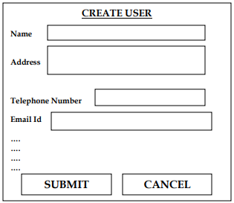

When the developer gives the above application for testing in the 1st build – the TE finds that clicking on the submit button goes to a blank page – this is a bug and is sent to the developer for defect fixing – when the new build comes in along with the defect fixes – the TE tests only the submit button. Here we are not going to test the other features of the 1st build and move to test the new features sent in the 2nd build. We are sure that fixing the submit button is not going to affect other features – so we test only the fixed defect.

Testing only the modified features is called Unit Regression Testing.

Let us consider another example,

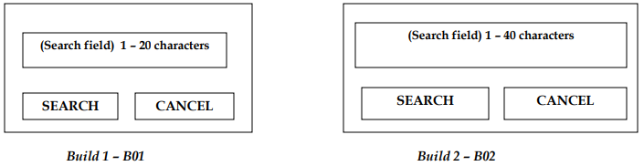

For the above application, in the 1st build – the developers develop a “search” field which accepts 1-20 characters. The TE test the search field using test case design techniques.

Now, the customer makes some changes in the requirements and requests that the “search” field be able to accept 1-40 characters. The TE tests only the search field to see if it accepts 1-40 characters and doesn‟t test for any other feature of the 1st build.

**Regional Regression Testing**

Testing the changes and impact regions is called Regional Regression Testing.

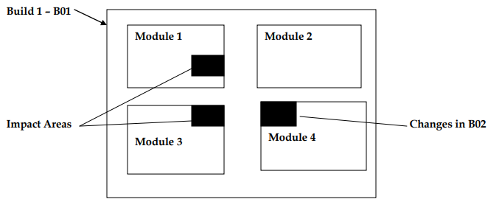

The module 1,2,3,4 is given by developers for testing during the 1st build. The TE finds a defect in Module 4. The defect report is sent to the developers and the development team fixes the bug and sends the 2nd build (Search field) 1 – 20 characters SEARCH CANCEL (Search field) 1 – 40 characters SEARCH CANCEL Module 1 Module 2 Module 3 Module 4 96 | P a g e in which the bug is fixed. Now, the TE realizes that defect fixing in module 4 has impacted some features in module 1 and 3. So, the TE first tests module 4 where the bug has been fixed and then tests the impact areas i.e, module 1 and module 3. This is known as regional regression testing.

**Full Regression Testing**

After 2 releases of the product, during the 3rd release – customer asks for adding 2 new features, deleting 1 feature and modifying 1 feature. Also some bugs needed to be fixed. The testing team after doing impact analysis find out that making all the above changes will lead to testing the entire product.

Thus, Testing the changes and all the remaining features is called Full Regression Testing.

**When do we do Full Regression Testing ?**

* When changes are more
* Whenever the changes are done in the root of the product. For example, JVM is the root of Java applications. Whenever any changes are made in JVM, the entire Java application is tested.

**Regional Regression Testing** is the most preferred method of regression testing. But the problem is, we may miss a lot of bugs doing Regional Regression Testing

We can solve this problem by the following method – when a product is given for testing, for the 1st ten cycles, we do regional regression testing, then for the 11th cycle, we do FRT. Again, for the next 10 cycles, we do RRT and for the 21st cycle we do FRT. Thus we continue like this, for the last ten cycles of the release – we do only FRT. Thus, following the above method – we can catch a lot of bugs.

**Retesting**

* Retesting is testing of a particular [bug](http://tryqa.com/what-is-defect-or-bugs-or-faults-in-software-testing/) after it has been fixed. Usually testers raise the bug when they find it while testing the product or its component. This bug is assigned to a developer and he fixes it. Post fixing the bug is assigned to the tester for its [verification](http://tryqa.com/what-is-verification-in-software-testing-or-what-is-software-verification/). This testing is known as retesting.
* Retesting is done by replicating the same scenario with the same data in the new build.
* to ensure that a particular defect has been fixed and it’s the functionality working as expected.
* In retesting those test cases are included which were failed earlier
* When a bug is raised and is rejected by the developer saying that it’s not re-creatable in their environment then in this case also the testers do the re-testing of the bug to ensure that whether it’s a genuine bug or not.
* The test cases of retesting cannot be automated.

**Difference between Retesting and Regression Testing.**

| Regression Testing | Retesting |
| --- | --- |
| Regression testing is to ensure that changes have not affected the unchanged part. | Retesting is done to make sure that the test cases which failed in the last execution are passed after the defects are fixed. |
| In Regression testing, the test cases which passed earlier can be included to check the functionality which was working earlier. | In Retesting, the cases which are failed earlier can be included to check if the functionality failed in an earlier build. |
| Regression test cases are derived from the functional specification, the user manuals, user tutorials, and defect reports in relation to corrected problems. | Test cases for Retesting cannot be prepared before starting testing. In Retesting, test cases that are failed in the prior execution are only re-executed. |
| Defect verification doesn’t fall under Regression testing. | Defect verification is coming under Retesting. |
| During regression testing test cases can be automated. | During retesting test cases can’t be automated. |

**How can testers decide the extent of regression?**

* Through experience and familiarity with the application
* Discussing with the developers

**Important Questions**

#### **What is the difference between regression testing the retesting?**

After a defect is found by testers and then it will be fixed by developers, it is again tested to confirm that the original defect is actually fixed. Retesting is done to make sure that the test cases which were failed earlier due to some defect are now passing after the defect is fixed.

Re-testing is a special technique needed to check the test cases that are not successful in the final execution and passed directly after the defects the repaired.

At the same time, Regressing testing is used to check the code either changes don’t have any adverse effect on the app functionality.

#### **What is Regression Testing?**

Once the application code is modified (for example after fixing a defect or some enhancement is done), we need to test and ensure the existing functionalities are working fine. This is called regression testing. For example if a new text box is added to a web page. Then we have to ensure the look and feel is not disturbed after introducing the text box also other fields which were already there in the page is working as expected. This is called regression testing.

This is a simple process of repeating test cases that is performed every time you modify the application functionality. It may be your code, design, or any other things related to the framework. The regression testing makes sure that changes will not impact or break the application functionality. So, every time a new version of an app is created, the bugs are fixed automatically.

#### **Is Regression testing done either manually or automated?**

Well, the best part is that it can be done in both ways either manually or automatically. You just have to check which technique suits your project requirements the most.

**How to perform the Regression testing?**

You are established with regression testing means repeating a set of test cases at any particular situation. When the app is small, regression testing can be performed manually. As the time moves on, the application starts getting more complicated and you need testing tools to speed up the process. In this case, regression testing is automated based on document specification.

#### **What are the steps involved while performing the regression testing?**

Every time changes are committed to an application or software program; the following steps need to be performed to carry out the regression testing. These are –

* Firstly, you need to check what type of changes are made to the application,
* Now you have to check how it may affect the application behavior.
* Take a closer look at the test case and determine either you need to perform a full, partial or unit testing. Don’t forget to check which testing suits your requirements the most.

#### **Regression Testing is needed to what extent?**

Well, it depends on application nature and scope of changes. If the scope is large then testing needs to perform thoroughly and it will take time. The complete information can be obtained from the developer about the scope, nature of applications, the total amount of change.

#### **What are the most common types of Regression tests?**

As this a repetitive tests process, a set of test cases can be used again for a new build. Keep in mind that selection of test cases should be done carefully and a number of counts also needs to be minimum. They should be improved continuously to meet the expectations of the new app.

If the scope of changes is large the continuous improvement may be difficult and needs extra efforts by testers. For this purpose, selective test cases will be used to save the overall time and money. These test cases are selected on the basis where it affects the most.

#### **What is the best time to perform the Regression Testing?**

Mostly, the regression testing is carried out throughout the development process and this is a continuous process too. Still, the best time to perform regression testing is after smoke testing or at the end of function testing after a short release.

**What are the best practices you followed to perform the Regression Testing successfully?**

* The test cases should run automatically daily in the evening when changes are made to the application.
* In this way, bugs can be identified at an early stage and it will be fixed immediately.
* It will also reduce the risks associated with the release by covering all the defects earliest at the end of the release cycle.

#### **Have you used any regression testing tool during any project?**

Yes, I have worked on selenium testing tool during my past work experiences. This is a popular automation tool where test scripts are automated as the convenience.

#### **When will the QA team perform Regression Testing?**

Regression testing is performed when a new build comes to the QA team and it is prone to bugs. Here, quality testers need to remove the bugs during each release cycle and make sure that application is still working fine as earlier.

#### **Can you explain the concept of Regression Testing with the help of Example?**

Yes, I will explain to you the concept of regression testing with a simple example and easy to understand for everyone. Take an example of a project having multiple modules like Admin module, employee module, personal details modules etc. there is some error in admin module like users are not able to login to their account even with the right credentials. So, this is an error and need to be fixed by the development team. Here, the Development team modified existing code or added new code to fix this issue and the module is sent back to the testing team again.